

COIMBATORE INSTITUTE OF TECHNOLOGY
(GOVERNMENT AIDED ANNA UNIVERSITY AFFILIATED)

NLP PROJECT
AI BASED RESUME INTELLIGENCE AND JOB
RECOMMENDATION SYSTEM

SUBJECT NAME : NATURAL LANGUAGE PROCESSING LABORATORY
SUBJECT CODE : 21MDSEL2

TEAM MEMBERS
1. HARINI .M - 2403717673822015 (MSc. DS - 3rd YEAR)
2. HEMAKUMAR .T - 2403717673821017 (MSc. DS - 3rd YEAR)

AI Based Resume Intelligence and Job Recommendation System

Abstract
The AI Based Resume Intelligence and Job Recommendation System is an intelligent Natural Language Processing (NLP) based platform designed to automate resume analysis, job description matching, skill gap identification, and personalized job recommendation. Traditional Applicant Tracking Systems (ATS) primarily depend on keyword matching, which may fail to recognize semantically similar skills, experiences, and qualifications expressed using different terminology. The proposed system addresses this limitation by combining NLP, semantic similarity, machine learning, and explainable scoring techniques to provide a more comprehensive evaluation of candidate–job compatibility.
The system accepts resumes in formats such as PDF and DOCX and extracts relevant information including personal details, technical skills, soft skills, education, work experience, projects, and certifications. Job descriptions are similarly processed to identify required skills, preferred skills, qualifications, experience requirements, and responsibilities. NLP preprocessing techniques such as text cleaning, tokenization, stop-word removal, lemmatization, named entity recognition, and skill normalization are applied to convert unstructured resume and job-description data into structured information.
To overcome the limitations of conventional keyword-based approaches, the system employs text embeddings and semantic similarity techniques to understand the contextual relationship between resume content and job requirements. A hybrid matching engine combines exact skill matching, normalized skill matching, semantic similarity, experience matching, education matching, and project relevance to calculate an overall candidate–job compatibility score.
The system further performs skill gap analysis, identifying matched, partially matched, and missing skills from the job description. Missing skills are prioritized according to their relevance to the target role, allowing candidates to understand which competencies they should develop. An explainable AI layer provides reasons behind the generated score instead of presenting only a numerical percentage. The system also provides ATS compatibility analysis, resume improvement suggestions, and personalized job recommendations by comparing the candidate profile against multiple job descriptions.
The proposed solution is implemented using Python, NLP libraries, Sentence Transformers, scikit-learn, FastAPI, React, and MongoDB. The architecture follows a modular pipeline consisting of document ingestion, text extraction, NLP preprocessing, information extraction, semantic embedding generation, matching and scoring, skill-gap analysis, recommendation generation, and visualization through an interactive dashboard.
The uniqueness of the proposed system lies in its integration of semantic resume–job matching, explainable scoring, prioritized skill-gap analysis, ATS simulation, resume improvement recommendations, and multi-job ranking within a single platform. Rather than simply determining whether a candidate matches a job, the system explains why the candidate matches, what is missing, what should be improved, and which other jobs are most suitable. This makes the proposed system a practical AI-driven career intelligence platform for both job seekers and recruitment environments.

FLOW ARCHITECURE
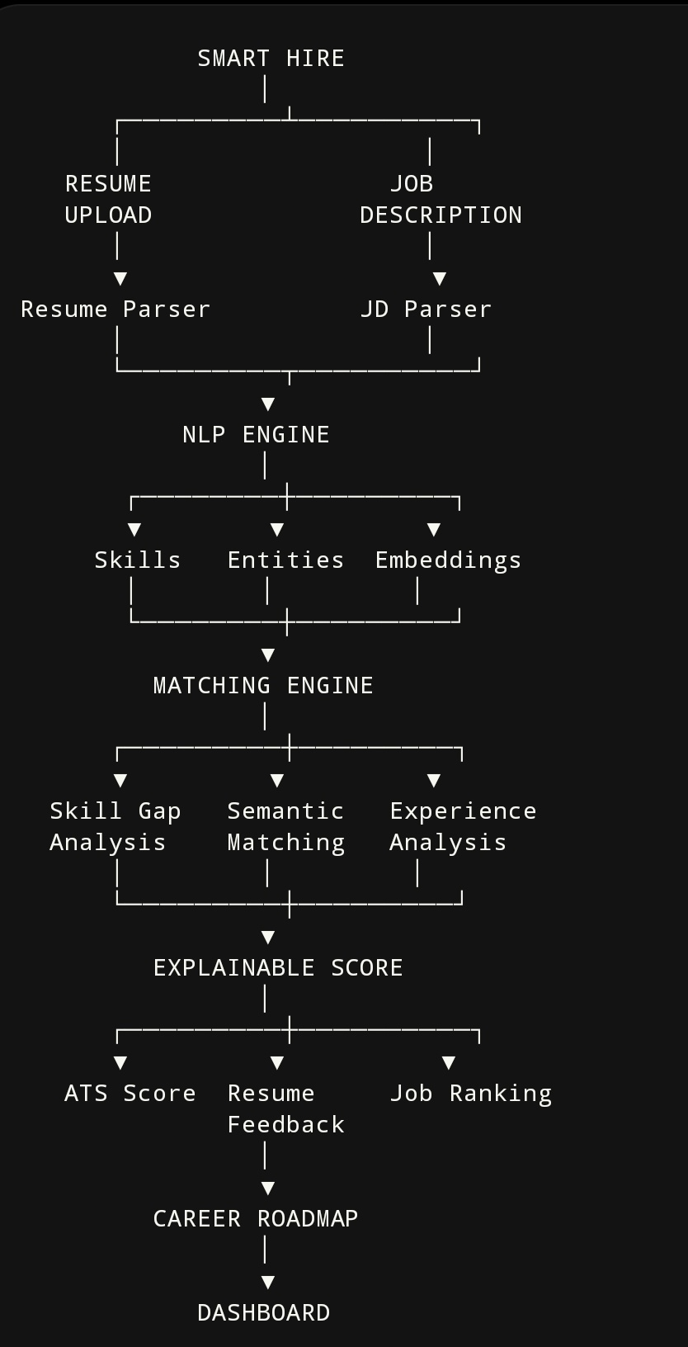

TECH STACKS
Layer | Technology
Programming Language | Python
NLP | spaCy, NLTK
Machine Learning | scikit-learn
Semantic NLP | Sentence Transformers
Document Processing | PyMuPDF, python-docx
Backend | FastAPI
Frontend | React
Database | MongoDB
Data Processing | Pandas, NumPy
Similarity Algorithm | Cosine Similarity + Semantic Similarity
Visualization | Chart.js / Recharts
API Communication | REST API

